**MINI PROJECT II**

**(2019-2020)**

**ZIRCON**

**(**Machine Learning**)**

SYNOPSIS

**Department of Computer Engineering & Applications**

**Institute of Engineering & Technology**



**SUBMITTED TO:**  **SUBMITTED BY:**

Mr. Sharad Gupta Vinayak Goyal (171500379)

(Assistant Professor) Himanshi Garg (171500131)

Sriyansh Jain (171500345)

Riya Agrawal (171500263)

**ACKNOWLEDGEMENT**

It gives us a great sense of pleasure to present the synopsis of the Mini Project II **(ZIRCON)** undertaken during B.Tech IIIrd Year. This project in itself is going to be an acknowledgement to the inspiration, drive and technical assistance will be contributed to it by many individuals.

We owe special debt of gratitude to **Mr. Sharad Gupta,** Assistant Professor Department of CEA, for providing us with an encouraging platform to develop this project, which thus helped us in shaping our abilities towards a constructive goal and for his constant support and guidance to our work. His sincerity, thoroughness and perseverance is been a constant source of inspiration for us. We believe that he will shower us with all his extensively experienced ideas and insightful comments at different stages of the project & also taught us about the latest industry-oriented technologies.

We also do not like to miss the opportunity to acknowledge the contribution of all faculty members of the department for their kind guidance and co-operation.

Vinayak Goyal

(171500379)

Himanshi Garg

(171500131)

Sriyansh Jain

(171500345)

Riya Agrawal

(171500263)

**ZIRCON**

(Machine Learning)

**Zircon** is important as it is associated with an increased number of available treatment options, increased survival, and improved quality of life. While there is no definitive method of preventing Disease, early detection provides the best chance of effective treatment.

For successful strategy to increase motivation for mass screening for detection of disease, three elements are needed:

**1)** Person at risk must be taught the necessity of the examination.

**2)** They must be made aware of the existence of the facility, which must be made easily accessible

**3)** They must be reassured that the examination is simple, effective, and safe. Early detection of disease is the only proven method that has the potential to reduce the stationary death rate from the disease. Until true primary prevention is developed, it is necessary to make mass screening ever more efficient, economical, and safe. At the same time, increasing efforts must be made to motivate people to accept such mass screening

**TABLE OF CONTENTS**

|  |  |
| --- | --- |
| **Acknowledgement………………………………………………………………………….**  **1. Introduction….…………………………………………………………………………...** | 5 |
| 1.1 Motivation………………………………………………………………………….... | 6 |
| 1.2 Problem Statement……….………………………………………………………….. | 7 |
| 1.3 Objective……...………..……………………………………………………………. | 7 |
|  |  |
| **2. Requirement ……………….…………………………………………………………….** | **8** |
| 2.1 Hardware requirements…….…………………...………………………………….... | 8 |
| 2.2 Software requirements………..….………………………………………………….. | 8 |
| 2.3 Technology used…….…….…………………….……………………………………  2.4 Pre-Requisites…………………………………………………………………………  2.5 Scope……………………………………….…………………………………………  2.6 Sample GUI…………………………………………………………………………... | 9  9  10  11 |
|  |
| **REFERENCES……………………………………………………………………….………** |
|  |
|  |
|  |
|  |
|  |
|  |
|  |
|  |
|  |

**1. Introduction**

Disease is a global and lethal disease, responsible for the ill-health and death of more than 1.4 million deaths each year, ranking HIV/AIDS as one of the leading causes of death from an infectious disease. An infectious disease that causes ill health and death in millions of people each year worldwide. Timely diagnosis and treatment is a key to full patient recovery.

Globally there are approximately 9 million new active Disease cases and 1.4 million deaths annually (Disease, 2014). Blood transcriptional signature can be used to differentiate between active and latent TB in HIV infected patients.

In 2011, the WHO began to back a diagnostics test for disease, called MODS (Microscopic Observed Drug Susceptibility). This low-cost method is based on the identification of M. Disease (MTB) growth in broth in 7–10 days from a sputum sample.

|  |  |
| --- | --- |
| **1.1 Motivation**  Early detection of Disease is important as it is associated with an increased number of available treatment options, increased survival, and improved quality of life. While there is no definitive method of preventing Disease, early detection provides the best chance of effective treatment.  For successful strategy to increase motivation for mass screening for detection of disease, three elements are needed:  1) Person at risk must be taught the necessity of the examination.  2) They must be made aware of the existence of the facility, which must be made easily accessible  3) They must be reassured that the examination is simple, effective, and safe. Mass screening for disease is the only proven method that has the potential to reduce the stationary death rate from the disease. Until true primary prevention is developed, it is necessary to make mass screening ever more efficient, economical, and safe. At the same time, increasing efforts must be made to motivate people to accept such mass screening.  **1.2 Problem Statement**    There is difficulty faced by peoples in diagnosing such a lethal disease like Disease. They do not found a simple and easy way to diagnose it with the help of several symptoms like persistent cough lasts for 3 weeks, fever, chills ,cough with bloody sputum, night sweats ,Loss of appetite ,Unexplained weight loss , etc. A weekend immune system, Diabetes, End stage kidney disease, certain cancers etc. can increase your risk of Harmful Disease  **1.3 Objective**    **ZIRCON** aims to provide a primary diagnose about the disease by taking various symptoms using different algorithms used in Machine Learning and find the disease as output.  **2.REQUIREMENTS**  **2.1 Hardware Requirement (**MINIMUM**)**   * GB RAM * 20 GB OF HARDDISK * Processor i3 (7th Gen) * 1024 x 768 Display     **2.2 Software Requirement-**   * SYSTEM SOFTWARE * Operating System (Windows 7, Linux) * APPLICATION SOFTWARE * Jupyter * Anaconda * Pandas * Numpy * Matlab   Programming: Python 3    **2.3 Technology used:**    **Machine Learning:-** Machine Learning is an application of Artificial Intelligence(AI) that provides systems the ability to automatically learn and improve from experience without being explicitly programmed. Machine Learning focuses on development of computer programs that can access data and use it learn for themselves.  **Types of machine learning:**   1. Supervised learning. 2. Unsupervised learning. 3. Reinforcement Learning.   **Classification:** In MACHINE LEARNING, Classification is the problem of identifying to which set of categories (sub-population) a new observations (or instance) whose category membership is known.  Example is assigning a given mail to the “Spam” or “Non-Spam”.  **Linear Regression:**  It is a linear approach to modeling the relationship between a scalar response (or dependent variable) and one or more explanatory variables (or independent variables). For more than one explanatory variable, the process is called **multiple linear Regression**.    **Naïve bayes:** In MACHINE LEARNING , Naïve bayes classifiers are a family of simple ‘probabilistic classifiers’ based on applying bayes theorem with strong (naïve) independence assumptions between the features. They are among the simplest Bayesian network models.  **Decision Tree:** Decision tree is one of the predictive modeling approaches used in statistics, data mining and machine learning. It uses a decision tree(as a predictive model) **t**o go from observations about an item(represented in the branches) to conclusions about item’s target value(represents the leaves).  **2.4 Pre-requisite:**  A person must be familiar to Python language, its modules, its packages, GUI using python, Machine Learning basics ,etc. His/her hands on python coding should be strong. He or She should have some knowledge of how to use Jupyter, Anaconda etc softwares. |  |

**2.5 Scope:**

Zircon will help people, as it will detect Disease by the symptoms entered by the user. By which they can take the proper treatment for the disease at early stage. It will be very helpful for harmful disease. They can chat in the absence of the doctor and get to know about their problem on the basis of the symptoms.

**2.6 Sample GUI**

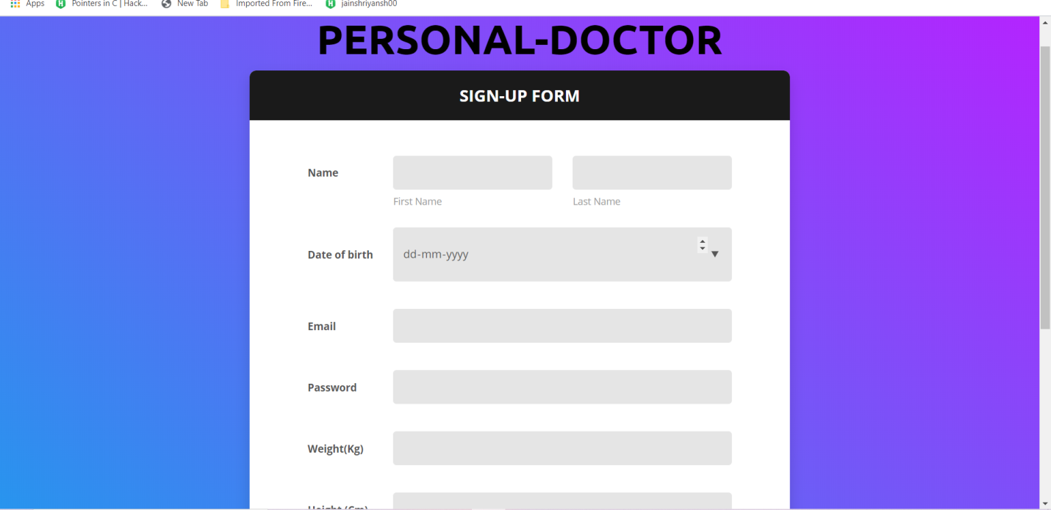

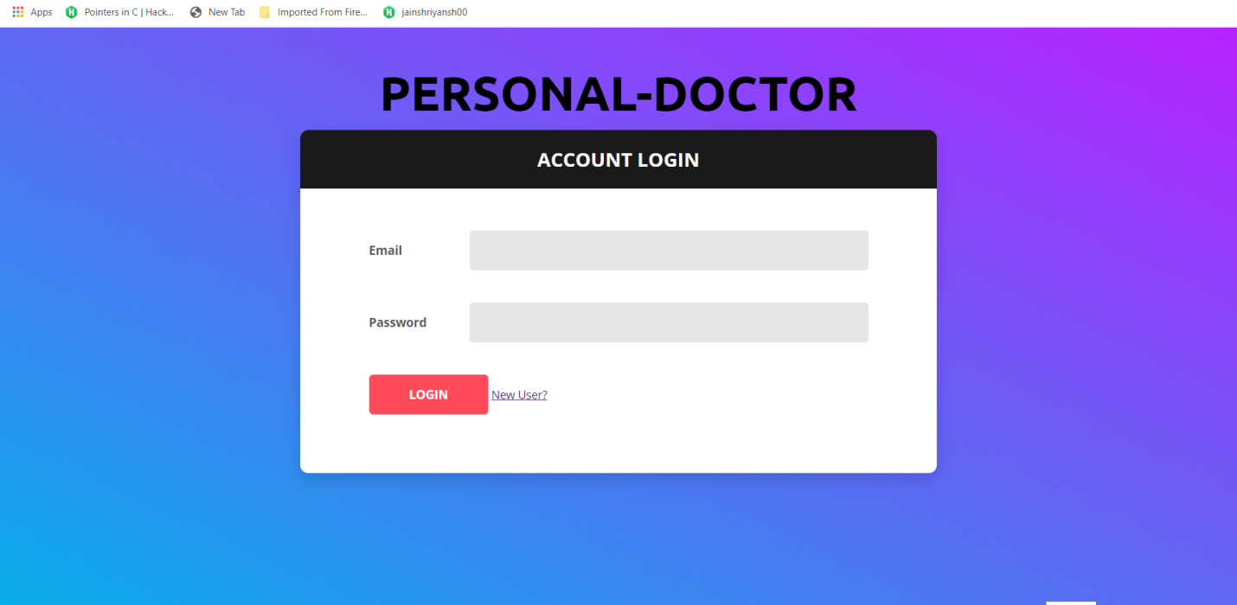

**References:**

* [**www.javatpoint.com**](http://www.javatpoint.com)
* [**www.programiz.com**](http://www.programiz.com)
* [**www.kaggle.com**](http://www.kaggle.com)
* [**www.youtube.com**](http://www.youtube.com)
* **Faculty Guideline:**
* **Mr. Sharad Gupta**
* **Mr. Rahul Pradhan**
* **Mr. Nikhil Govil**
* **Mr. Manish Raj**
* **Mr. Amir Khan**